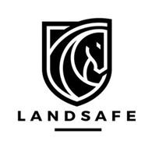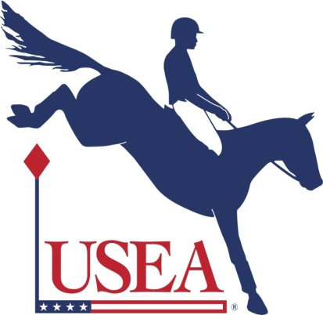

LandSafe Clinic
with Danny and Keli Warrington
April 14 - 15, 2018
Cost: $350 ($300 for USEA members)
Closing date: April 1
Place: Blue Heron Stables, 86 Stanavage Rd, Colchester, CT 06415 (indoor arena)
Contact: Mickey Lorenzen, 860-501-3242 lorenzenmjlrbl@comcast.net
For additional information: landsafeequestrian.com
Rider fall safety training program-all rider levels, all disciplines. Goals include safety education for both riders and parents
This is a 2 day clinic which will teach participants tumbling techniques on mats (Day 1) and progresses to the use of these skills on mechanical horse simulator (Day 2). See website above for more details.

